Teacher Notes for
"Negative Feedback, Homeostasis, and Positive Feedback"

Analysis and discussion questions develop student understanding of negative and positive feedback and homeostasis. For example, students develop a model of negative feedback regulation of body temperature; this model includes a temperature control center in the brain that uses information about differences between a setpoint and actual body temperature to regulate sweating, shivering, and changes in blood flow to the skin. The setpoint for negative feedback can be changed; for example, in response to an infection the temperature setpoint can be increased, resulting in a fever. Negative feedback contributes to homeostasis. Sometimes negative feedback does not function properly. For example, diabetes results from abnormalities in negative feedback regulation of blood glucose levels. Finally, students analyze how positive feedback contributes to rapid change (e.g., rapid formation of a platelet plug).

I estimate that this activity will take roughly 50-70 minutes of class time. If you prefer a shorter activity, you can omit the optional section on diabetes. If you prefer an introduction to these topics that includes a hands-on activity, please see “Negative Feedback, Homeostasis, and Positive Feedback – Examples and Concepts” (https://serendipstudio.org/exchange/waldron/breathing).

Table of Contents
Learning Goals – pages 1-2
Instructional Suggestions and Background Information
General – page 2
How is your body temperature regulated? – pages 3-7
Diabetes – A Failure of Negative Feedback Regulation of Blood Glucose Levels – pages 7-11
Positive feedback produces rapid change. – pages 11-12
Additional Information – pages 12-13

Learning Goals
In accord with the Next Generation Science Standards:
- Students learn the following Disciplinary Core Idea:
- LS1.A "Feedback mechanisms maintain a living system's internal conditions within certain limits and mediate behaviors, allowing it to remain alive and functional even as external conditions change within some range. Feedback mechanisms can encourage (through positive feedback) or discourage (negative feedback) what is going on inside the living system."
- Students engage in recommended Scientific Practices, including:
- “Developing and Using Models – Develop, revise, and/or use a model based on evidence to illustrate and/or predict the relationships between systems or between components of the system.”
- “Constructing Explanations – Apply scientific ideas, principles, and/or evidence to provide an explanation of phenomena…".
- Students learn the Crosscutting Concept, "Stability and Change – Systems in dynamic equilibrium are stable due to a balance of feedback mechanisms."
- This activity helps students to prepare for the Performance Expectation:
- HS-LS1-3. "Plan and conduct an investigation to provide evidence that feedback
mechanisms maintain homeostasis."

Additional Content Learning Goals
- Negative feedback occurs when a change in a regulated variable stimulates a response which reverses the initial change and brings the regulated variable back to the setpoint.
- Negative feedback does not mean that body temperature is always constant. For example, cells that are fighting an infection can release a chemical signal that is carried by the blood to the temperature control center, where this chemical signal can increase the setpoint for temperature regulation, resulting in a fever.
- Homeostasis refers to the maintenance of relatively constant internal conditions. Negative feedback plays an important role in maintaining homeostasis.
- Diabetes occurs when negative feedback regulation of blood glucose levels fails, either because the pancreas can’t secrete insulin (type 1 diabetes) or because the body’s cells have become less sensitive to insulin (type 2 diabetes).
- Positive feedback occurs when a change in a variable triggers a response which causes more change in the same direction. Positive feedback is useful when there is an advantage to making a rapid change. For example, positive feedback contributes to rapid formation of a platelet plug which helps to prevent excessive blood loss when a blood vessel is injured.

Instructional Suggestions and Background Information
You can maximize student participation and learning, by having pairs of students work to complete each group of related questions and then having a class discussion after each group of related questions. In each discussion, you can probe student thinking and help them develop a sound understanding of the concepts and information covered before moving on to the next group of related questions.

If your students are learning online, I recommend that they use the Google Doc version of the Student Handout, which is available at https://serendipstudio.org/exchange/bioactivities/homeostasis. To answer questions 2, 4-5, 6c-7, and 11, students can either print the relevant pages, write on them, and send you pictures, or they will need to know how to modify a drawing online. They can double-click on the relevant drawing in the Google Doc, which will open a drawing window. Then, they can use the editing tools to answer the questions.

You may want to revise the GoogleDoc or Word document to prepare a version of the Student Handout that will be more suitable for your students; if you do this, please check the format by viewing the PDF.

A key is available upon request to Ingrid Waldron (iwaldron@upenn.edu). The following paragraphs provide additional instructional suggestions and background information – some for inclusion in your class discussions and some to provide you with relevant background that may be useful for your understanding and/or for responding to student questions.
How is your body temperature regulated?
This is the driving question for this section of the activity.

In humans and other mammals, negative feedback regulation maintains a relatively high body temperature, which allows mammals to move quickly even when environmental temperatures are low. This type of thermoregulation depends on a relatively high metabolic rate which requires a high caloric intake. Mammals and birds are homeotherms, in contrast with most other types of animals which are poikilotherms (core body temperature generally varies with the environmental temperature, although some poikilotherms use behaviors like moving into or out of the sun to increase or decrease body temperature).

For question 1, you may want to encourage your students to consider the effects of temperature on the structure and function of molecules. For example, enzymes have optimum temperatures; if body temperature gets too low or too high, enzymes will not function properly, so the chemical reactions required for life will slow down. If body temperature gets really low, body fluids can freeze and the ice crystals will damage cells (e.g. resulting in frostbite). If body temperature gets too high a person may develop heat exhaustion or even heat stroke.

For question 2, you may want to discuss how physical activity, including shivering, results in increased production of heat (thermal energy). All types of energy conversion are inefficient and result in the production of heat. During cellular respiration, only about 50% of the energy in nutrient molecules is transferred to ATP and the other 50% is converted to heat. During muscle activity, only about 20-25% of the chemical energy expended is captured in the kinetic energy of muscle contraction and the rest of the energy is converted to heat.

Question 3 should stimulate students to begin thinking about how body temperature is regulated. Their preliminary ideas will be developed further in questions 4 and 5. Some of your students should be able to figure out that the temperature control center needs sensory information about the body’s temperature in order to stimulate shivering or sweating when needed. If a student suggests that the temperature control center needs information about environmental temperature, ask them to think about what happens when a person with multiple layers of warm clothing is engaged in vigorous physical activity outside in cold weather; this should help them understand that temperature regulation responds to body temperature, including core temperature and skin temperature (which of course can be influenced by environmental temperature). Students probably know that the brain controls muscle activity (including shivering). Students may be less familiar with neural control of sweating; however, thinking about how anxiety or fear can stimulate sweating may help them to understand the importance of neural control of sweating (https://en.m.wikipedia.org/wiki/Sweat_gland).

This figure shows a general flowchart with the components needed for negative feedback regulation. For regulation of body temperature, the sensors are temperature receptors in the temperature control center in the hypothalamus, other parts of the central nervous system, the skin, and abdominal organs. The effectors are the sweat glands, skeletal muscles, and blood vessels. | 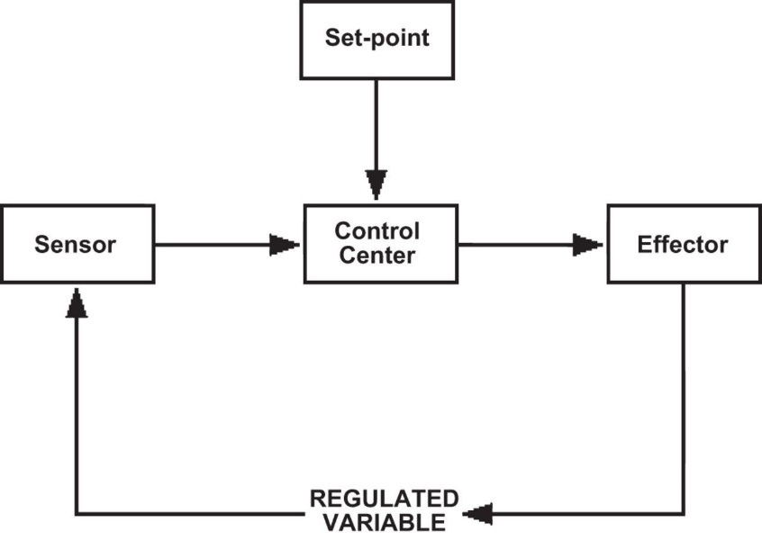  (https://physiology.org/doi/full/10.1152/advan.00107.2015)

Several complexities are not included in the Student Handout. For example, the Student Handout refers to a temperature control center in the singular, but human body temperature is regulated by several interconnected regions within the hypothalamus, with at least one region that stimulates responses that warm the body and another that stimulates responses that cool the body. Also, a setpoint is not really a single point, but rather a narrow range of values.

The Student Handout gives the set point for normal body temperature as ~37°C = ~98.6°F. As shown in this figure, this is a good estimate for rectal temperatures. However, oral temperatures in healthy individuals tend to be lower, with a mean value of ~36.4°C. It should also be mentioned that body temperature varies by time of day, with lower temperatures in the early morning and higher temperatures in the late afternoon or early evening. | 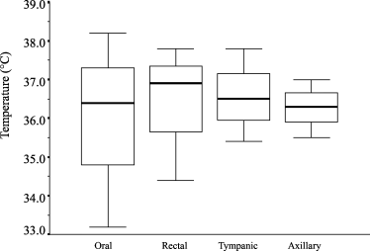  The results from 20 studies with strong or fairly strong evidence of normal oral, rectal, tympanic (ear), and axillary (armpit) temperature (°C) in adult men and women are presented. Temperature is obtainable as mean value (bold lines), 1st and 3rd quartiles (unfilled bars) and range (thin lines). (From Sund-Levander et al, 2002, Scand. J. Caring Sci. 16:122-8)

After question 4, you may want to ask students one or more of these additional questions:
- Why should you drink more water if you are exercising in a hot environment?
- Why is a person’s temperature more likely to get dangerously high if he or she is exercising in an environment that is both hot and humid? (In a humid environment, sweat tends to drip off the body instead of evaporating, so the cooling effect of sweating is reduced.)

As you discuss question 6, you should point out the general principle that body temperature depends on the balance between the amount of heat generated by the body’s metabolism
(influenced e.g. by shivering and exercise) and the amount of heat lost to or gained from the environment (influenced e.g. by sweating and changes in circulation to the skin). This figure shows that changes in blood flow in a cold environment maintain core body temperature while allowing the extremities and body surface to become cooler. Under many circumstances, temperature regulation near the setpoint is accomplished by small changes in metabolism and blood flow, with little or no shivering or sweating.  (Figure showing distribution of body temperatures in warm vs. cold environments from http://www.bbc.co.uk/staticarchive/b57e4fc3b663a79474c8dcf51ed31b0faf72f98f.gif) | 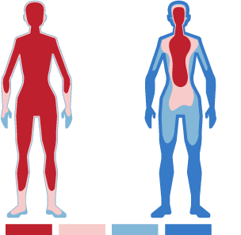

You may want to include the following question, which asks students to relate the changes in blood flow in response to temperature to a familiar phenomenon, bruises and black eyes.

If an injury causes damage to the small blood vessels just under the surface of the skin, the blood that leaks out of the injured blood vessels can cause swelling and a black and blue bruise or a black eye.

7. Doctors advise cooling the injured area (for about ten minutes several times during the first day or two). How could cooling the injured area minimize swelling and the dark color of a bruise
or black eye? (Hint: Local skin blood flow can change in response to local temperature.)

Cooling the bruised area immediately after an injury reduces blood flow to the damaged capillaries near the surface of the skin; this reduces the amount of blood that leaks out to cause swelling and discoloration. A bag of ice or frozen vegetables should be wrapped in a washcloth and applied for about 10 minutes several times during the first day or two. For additional information, see https://www.webmd.com/first-aid/helping-bruise-heal#1 and https://www.medicalnewstoday.com/articles/249231.php.

Question 7b will help students realize that different flowcharts can represent the same negative feedback model.

Before question 8, you may want to show the 3.6-minute video on homeostasis, negative feedback and temperature regulation available at https://www.khanacademy.org/science/ap-biology/cell-communication-and-cell-cycle/feedback/v/homeostasis. (This video mentions goose bumps which can result from exposure to cold. In other mammals with dense fur, this response traps a layer of air that helps to insulate the skin surface from the environment and thus reduces heat loss. In humans, this response is relatively ineffective because the hair on our skin is not thick enough to trap an insulating layer of air.)

As discussed on page 4 of the Student Handout, negative feedback regulation does not imply that temperature is the same at all times. You can change the set point on the thermostat in a home and, similarly, physiological responses can change your body's set point for temperature regulation. For example, when you have an infection, the phagocytic cells that defend against bacteria and viruses send a chemical signal to the temperature control center in the brain. This chemical signal increases the set point for temperature regulation, so you develop a fever. When a person’s set point for body temperature is increased above normal, but body temperature is normal, then the person may feel chills and shiver until actual body temperature increases to the new setpoint. Fever helps the immune system fight the infection, because the increase in temperature generally increases the immune response and decreases population growth for many types of infectious microorganisms.

Question 9 provides the opportunity to point out that in biology, “why” can have two distinct meanings. “Why” questions can inquire about the mechanism, e.g. the sequence of steps that result in higher temperatures during an infection; this type of why question usually can be worded as a “how” question. “Why” questions can also inquire about the adaptive value of a response such as a fever during infection; this type of why question makes sense in biology because natural selection results in adaptations.

Sometimes an increase in body temperature is not due to a change in set point, but instead is due to inability of the negative feedback mechanisms to cope with the amount of heat being generated or lost. For example, during exercise, body temperature tends to increase because the increased energy expenditure (up to 15-fold above resting levels) results in increased heat production which may exceed the ability of the body to get rid of heat. Usually, this results in fluctuation of body temperature within an acceptable range (as shown in the figure on the right). In extreme circumstances, this can result in heat exhaustion or heat stroke (see footnote 5 on page 3).
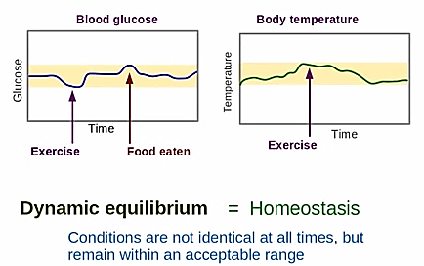
(https://www.youtube.com/watch?v=SRgHeHQ9ud0)

As you discuss this section of the activity, you will probably want to discuss the following important points about negative feedback regulation of internal body temperature.
- Negative feedback maintains body temperature within a narrow range by changing other aspects of body physiology (e.g., sweating, shivering, blood flow to the skin) and behavior (e.g., putting on a sweater or moving out of the sun).
- Negative feedback often operates via more than one type of physiological response, as well as changes in behavior
- The key stimulus for these changes is the discrepancy between the setpoint temperature and the actual body temperature.

Diabetes – A Failure of Negative Feedback Regulation of Blood Glucose Levels
Many students are familiar with at least some aspects of diabetes mellitus, so you may want to begin by asking your students, “What do you know about diabetes?” You can weave their responses (both accurate and inaccurate) into your discussions of this section.

Chronic high blood glucose levels can damage blood vessels and nerves, which can result in heart disease, stroke, kidney disease, blindness, and/or the need for amputations. Hypoglycemia can also be a problem (e.g., when diabetics inject too much insulin). The brain is highly dependent on glucose for cellular respiration to produce ATP. Symptoms of low blood glucose include fatigue, shakiness and anxiety. Severe hypoglycemia can result in seizure, loss of consciousness, and even death.

The negative feedback diagram immediately preceding question 11 shows normal regulation of blood glucose levels. Increased blood glucose levels after a meal stimulate the pancreas to secrete the hormone, insulin, which travels in the blood to cells all over the body. In response to insulin, the liver takes up glucose and stores it in the polymer glycogen. Most cells respond to the hormone insulin by taking up glucose, which is used for cellular respiration to produce ATP. For example, glucose uptake by muscle cells depends on the glucose transporter GLUT-4, which is inserted in the muscle plasma membrane in response to insulin or muscle contraction (see figure below). In contrast, the brain requires a constant supply of glucose and has glucose transporter molecules that are always present in the plasma membrane.

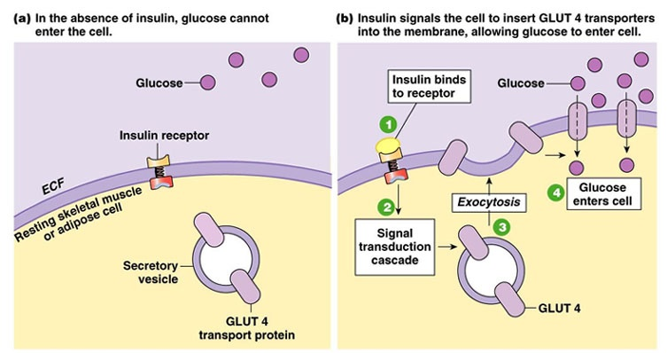
(https://fanaticcook.files.wordpress.com/2014/06/glut4.jpg)

When blood glucose levels begin to fall too low (e.g., if a person has not eaten for a while), the pancreas secretes the hormone, glucagon. Glucagon stimulates the liver to break down glycogen to glucose and convert amino acids to glucose; both of these responses increase blood glucose levels. The figure below shows that other hormones also help to increase blood glucose when levels have fallen too low. In contrast, insulin is the only hormone that acts to lower blood glucose levels that are too high.
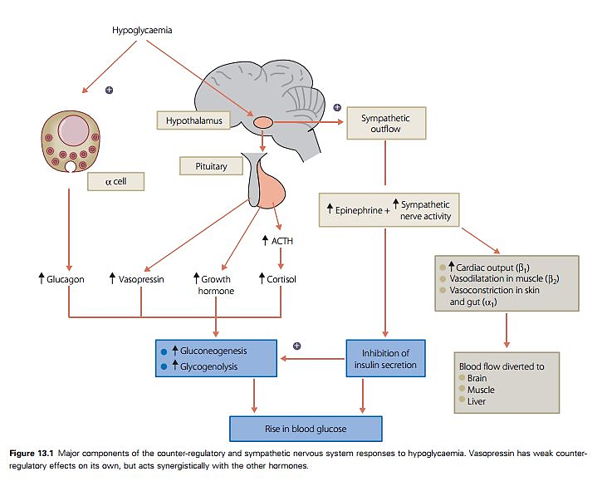
In this figure, hypoglycemia refers to low blood glucose. The alpha cells are located in the pancreas. (The alpha cells secrete glucagon, as opposed to the beta cells which secrete insulin.) Gluconeogenesis refers to the synthesis of glucose from amino acids or fatty acids. (Figure from https://www.diabetesincontrol.com/handbook-of-diabetes-4th-edition-excerpt-12-hypoglycemia/).

Notice that the brain controls levels of several of these hormones. For example, a stress response can increase the release of epinephrine (adrenaline) and cortisol, and both these hormones stimulate an increase in blood glucose levels. Thus, the effects of stress can increase blood glucose which can provide fuel for a fight or flight response. These effects of stress can be thought of as increasing the setpoint for negative feedback regulation of blood glucose levels.

It should be noted that, even in the absence of stress, healthy subjects’ blood glucose levels vary quite a bit (see figure below). This type of variation is often observed when negative feedback regulation involves relatively slow hormonal and metabolic responses.
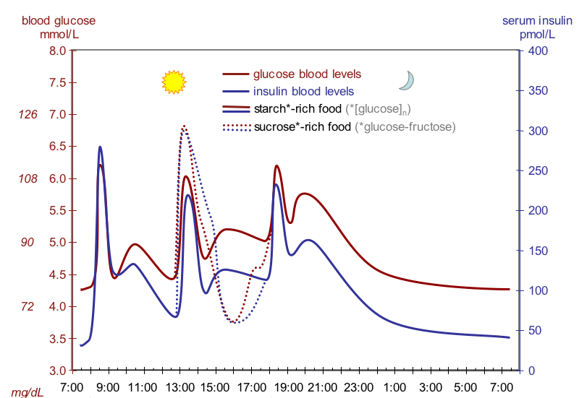
This figure shows fluctuation of blood glucose and insulin in subjects who received a standardized breakfast, lunch, dinner and late small “supper”; about 50% of the calories in these meals were from carbohydrates (starch-rich food or sucrose-rich food); https://academic.oup.com/ajcn/article/67/6/1186/4666071; https://upload.wikimedia.org/wikipedia/commons/4/4d/Suckale08_fig3_glucose_insulin_day.png).

In people with diabetes, negative feedback regulation of blood glucose levels does not function normally. Unless the diabetes is adequately treated, blood glucose levels are higher than normal, particularly after a meal.

Type 1 diabetes results from an autoimmune reaction that destroys the beta cells in the pancreas, so the pancreas is unable to secrete insulin. People with type 1 diabetes must monitor their blood sugar levels and inject insulin as needed; both of these processes can be automated (https://my.clevelandclinic.org/health/diseases/21500-type-1-diabetes).

Type 2 diabetes accounts for 90-95% of diabetes cases in the US. Type 2 diabetes begins with insulin resistance. This means that, for a given amount of insulin, the person’s cells (including liver cells) take up less glucose from the blood. This results in higher blood glucose levels, which stimulates the pancreas to secrete more insulin. In type 2 diabetes, the pancreas cannot secrete enough insulin to overcome the insulin resistance; this results in blood glucose levels that are higher than normal. Recommendations to prevent and control type 2 diabetes include regular exercise, avoiding weight gain (if needed, weight loss), and avoiding simple carbohydrates (e.g. sugar) (https://www.medicinenet.com/diabetic_diet_for_type_2_diabetes/article.htm).

Useful general introductions to diabetes mellitus are available at:
- https://my.clevelandclinic.org/health/diseases/21500-type-1-diabetes
- https://my.clevelandclinic.org/health/diseases/21501-type-2-diabetes
- https://www.cdc.gov/diabetes/basics/type2.html
- https://www.mayoclinic.org/diseases-conditions/diabetes/symptoms-causes/syc-20371444.
Useful discussions of societal changes to reduce rates of type 2 diabetes are available at:
- https://www.nytimes.com/2022/10/05/health/diabetes-prevention-diet.html
- https://health.gov/about-odphp/committees-workgroups/national-clinical-care-commission/report-congress

Positive feedback produces rapid change.
Positive feedback is useful when there is an advantage to a rapid transition between two states, e.g., from blood flowing freely in a blood vessel to formation of a platelet plug in an injured blood vessel. This example illustrates how positive feedback can contribute to homeostasis; rapid platelet plug formation prevents excessive loss of blood, which conserves fluid and helps to maintain blood pressure. The platelet plug is reinforced by a blood clot which provides greater mechanical strength (see figure on the last page of these Teacher Notes). The figure below provides additional information about positive feedback in the formation of a platelet plug. Undamaged endothelial cells in the lining of the blood vessels secrete chemical signals that inhibit platelet aggregation and blood clot formation, so the platelet plug and blood clot are limited to the location where the endothelium has been damaged.

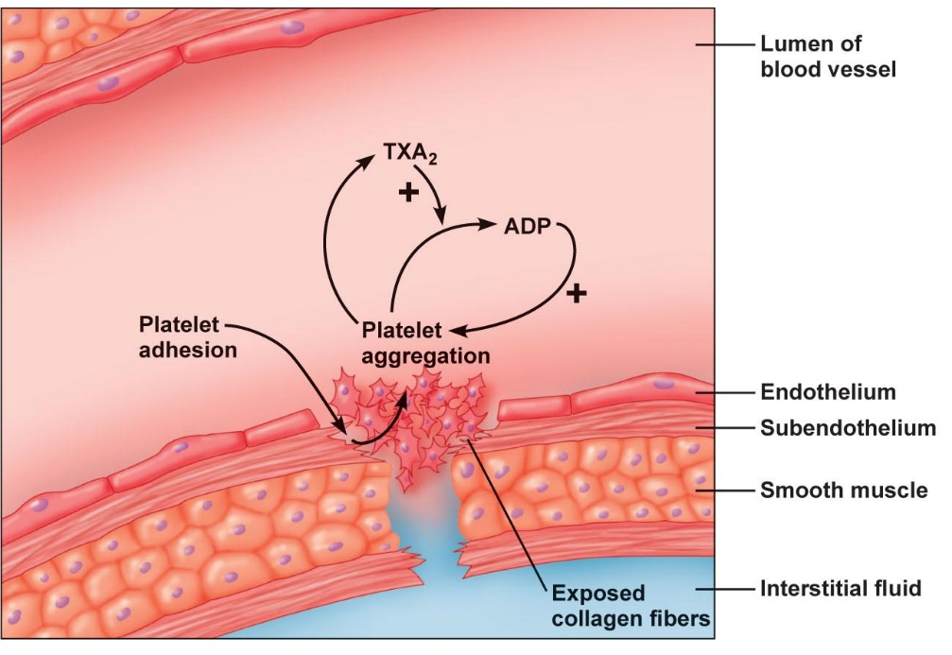
This limits the platelet plug and blood clot to the location where the endothelium has been damaged.
Undamaged endothelial cells secrete prostacyclin and nitric oxide which inhibit platelet aggregation.
TXA₂ also stimulates constriction of the blood vessel which helps to minimize blood loss.
(From Principles of Human Physiology, Third Edition by Stanfield and Germann)

Question 17 provides a brief test of student understanding of the difference between negative and positive feedback. After question 17, you may want to add this question.

18. What would go wrong if your body used positive feedback to regulate body temperature? For example, what would happen if a person shivered when temperature increased?

With respect to question 18 in the Student Handout, the term feedback is appropriate since, for both positive and negative feedback, an initial change in a variable stimulates a response in the same variable. Positive feedback adds to the initial change, while negative feedback reverses or subtracts from the initial change.

For a review, you may want to show your students the 6-minute video “Homeostasis and Negative/Positive Feedback” (https://www.youtube.co who m/watch?v=Iz0Q9nTZCw4).

Sources of Figures in Student Handout
- Figure showing temperature control center – adapted from https://upload.wikimedia.org/wikipedia/commons/thumb/5/5a/Nervous_system_diagram_unlabeled.svg/466px-Nervous_system_diagram_unlabeled.svg.png
- Figure of skin circulation – adapted from https://78.media.tumblr.com/74c35708184c53b27af3bb0a70257805/tumblr_inline_ny6vbluwyO1syb5xa_500.png
- Figure of negative feedback regulation of body temperature on bottom of page 3 – adapted from https://d2jmvrsizmvf4x.cloudfront.net/42IFA2i2ShiS1MpwS2yL_thermoregulation-campbell.jpg
- Figure of boy shivering from https://encrypted-tbn0.gstatic.com/images?q=tbn:ANd9GcTSJEL0YJQn7nHmYQ3-i4pav8xOC35j9mKT4jSohUH011AvoT6ib2g3-D9IpsVUjPYA0d0&usqp=CAU
- Figure of negative feedback regulation of blood glucose levels – adapted from https://image1.slideserve.com/3308142/slide1-n.jpg.
- Figure of positive feedback in platelet plug formation from https://slideplayer.com/slide/5948312/20/images/24/1+occurs+in+blood+vessel+wall.+Positive+feedback+cycle+is+initiated.+3.jpg
Other figures were constructed by the author.

Physiological Reactions to Blood Vessel Injury, including Clot Formation

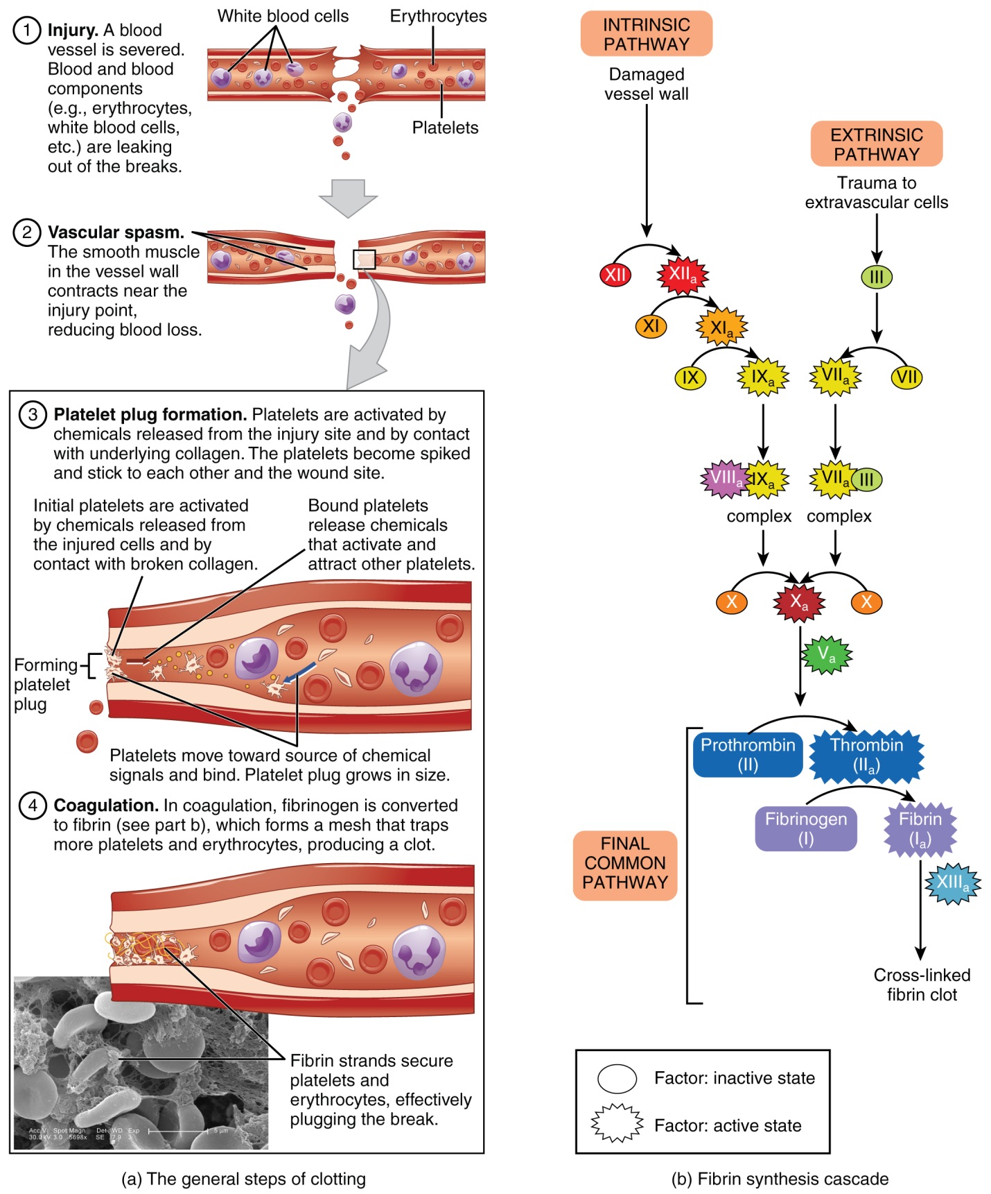
(http://philschatz.com/anatomy-book/resources/1909_Blood_Clotting.jpg)

By Dr. Ingrid Waldron, Dept Biology, University of Pennsylvania, © 2023. These Teacher Notes and the related Student Handout are available at https://serendipstudio.org/exchange/bioactivities/homeostasis.
Quotations are from Next Generation Science Standards (https://www.nextgenscience.org/sites/default/files/HS%20LS%20topics%20combined%206.13.13.pdf).
To draw a shape, at the top of the page, find and click Shape, then choose the shape you want to use, and finally click and drag on the canvas to draw your shape. To insert text, at the top of the page, click Insert and then click Text Box, type your text, and drag the text box to where you want it. When you are done, click Save and Close.
See https://emedicine.medscape.com/article/926249-overview#a3 for additional physiological mechanisms for the damage caused by frostbite.
Heat exhaustion may result if a person exercises vigorously when the weather is very hot and humid; hot, humid weather decreases the body's ability to get rid of excess heat, due to reduced radiation of heat from the body and sweat dripping from the body without evaporating. Fluid loss through sweating, together with peripheral vasodilation to facilitate heat loss, can result in reduced blood pressure and heat exhaustion. Heat exhaustion can be protective if it prevents continued exertion when the body is unable to give off enough heat. If excessive exertion continues in a hot and humid environment, this can result in heat stroke and even death. Escalating body temperature can result if the body stops sweating to conserve fluids and the cardiovascular system directs blood away from the body surface in order to maintain needed blood flow to the brain and other vital body organs. If internal core temperature reaches 106°F (41°C) most people suffer convulsions, and if internal core temperature exceeds 110°F (43.3°C) neuron malfunction and irreversible damage to proteins are likely to prove fatal. Additional information is available in "Heat and exercise: Keeping cool in hot weather" (http://www.mayoclinic.com/health/exercise/HQ00316).
Throughout this activity we have used heat as a more familiar, although somewhat inaccurate, term for thermal energy. "Thermal energy refers to the energy contained within a system that is responsible for its temperature. Heat is the flow of thermal energy." (https://www.khanacademy.org/science/physics/work-and-energy/work-and-energy-tutorial/a/what-is-thermal-energy) Heat is "energy that is transferred from one body to another as the result of a difference in temperature" (https://www.britannica.com/science/heat). Thus, throughout the Student Handout and Teacher Notes, it would be more accurate to substitute "thermal energy" for the term "heat".
Figure of a man with black eyes from https://i.ytimg.com/vi/0vfFDJ_4jyM/mqdefault.jpg
For an excellent discussion of homeostasis and negative feedback, see "A Physiologist’s View of Homeostasis" (https://physiology.org/doi/full/10.1152/advan.00107.2015).
Regulation of building temperature is not a good model for regulation of body temperature. Regulation of building temperature typically turns a heater or air conditioner on and off. In contrast, regulation of body temperature involves much more continuous and graded responses.
The same chemical signal that stimulates fever also triggers a tired, achy feeling so you want to rest, which helps your body mobilize resources to fight the infection. "Brain damage from a fever generally will not occur unless the fever is over 107.6°F (42°C). Untreated fevers caused by infection will seldom go over 105°F (40.6°C) unless the child is overdressed or in a hot place." (https://medlineplus.gov/ency/article/003090.htm) However, a fever may indicate a serious infection that should be treated medically.
Another example of positive feedback occurs during childbirth (see https://bio.libretexts.org/Bookshelves/Introductory_and_General_Biology/Book%3A_General_Biology_(Boundless)/33%3A_The_Animal_Body-_Basic_Form_and_Function/33.12%3A_Homeostasis_-_Control_of_Homeostasis). This positive feedback helps to speed up the transition from a fetus in the uterus receiving oxygen via the placenta to a baby that has been born and is breathing on his or her own. Of course, positive feedback is not the only way that the body achieves rapid change; for example, neural control of muscles or secretory organs can also produce rapid responses.

